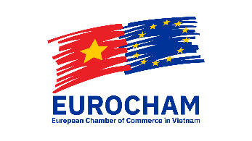

Cosmetics Sector Committee Membership Application Form
Company name:
Details of the contact person for all administrative matters: | Name:
 | Address:
 | Phone:
 | Email:
Company website:
First appointed member representative, with voting right* (compulsory): | Mr./Mrs.
 | Title:
 | Personal phone:
 | E-mail:
Second appointed member representative (optional): | Mr./Mrs.
 | Title:
 | Personal phone:
 | E-mail:
Third appointed member representative (optional): | Mr./Mrs.
 | Title:
 | Personal phone:
 | E-mail:
EuroCham membership information: | EuroCham member:  - Yes  - No  - Currently applying | Type of EuroCham membership:  - Large corporate member  - SME corporate member  - Individual member  - Honorary member

……, date…………………………….

Approved by:

* The appointed company representatives are the primary contacts for the Cosmetics SC when communicating information.
** Each member of the EuroCham Cosmetics SC shall have one single voting right which is of the primary appointed member representative. In case the primary appointed representative is unavailable to vote at a meeting, he or she may authorize someone else to vote on behalf of the member, by informing the Cosmetics SC in advance of the meeting, in writing.

For more information, please contact the EuroCham Sector Committee Secretariat via phone no. (+84) 838272715 – extension no. 115/117 or via e-mail: sec.comms@eurochamvn.org.

