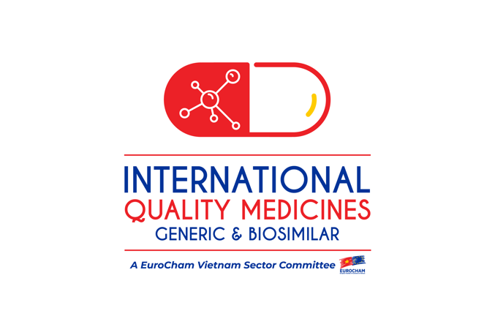

General information
The International Quality Medicines (IQMED) – Generic & Biosimilar, former International Quality Generics (IQGx) Sector Committee, was established in October 2016 under EuroCham's Healthcare Forum. With the aim to pool viewpoints and superior practices towards providing solutions for an affordable, high-quality, and sustainable supply source for branded generic drugs in Vietnam, the Sector Committee has created a platform where issues and solutions can be discussed among interest-shared business professionals in the industry.

The activities of the EuroCham IQMED – Generics & Biosimilar Sector Committee, guided by a strong commitment to their common mission, focus on a baseline of key interests: delivering an affordable, high quality, sustainable supply of trusted branded generic medicines and services to Vietnamese people; policy advocacy and collaboration with key healthcare stakeholders such as the Government, providers and payers in Vietnam, towards building efficient legal frameworks and implementation platforms.

The IQMED – Generics & Biosimilar Sector Committee also contributes to the annual EuroCham Whitebook, focusing on specific recommendations to the Vietnamese Government towards an ever-improving business environment for the healthcare industry and helping patients get better access to affordable and high-quality pharmaceutical products in the country.

The IQMED – Generic & Biosimilar Sector Committee is in the process of extending its members, as well as discussing priority topics for the group’s future internal work, activities and projects.

How can members join SCs:
To be eligible for IQMED membership, a company shall meet all of the following criteria:
- Must be a member of EuroCham.
- Must be a foreign-direct-invested or foreign pharmaceutical company with representative office in Vietnam. If the Member has a parent company, the parent company must also be a foreign company. [N.B. Separate legal entities belonging to the same multinational company shall be deemed to constitute a single company.
- Must have product marketed in minimum three (3) markets in European Union (EU), Japan, Australia and New Zealand; and all together minimum ten (10) countries in Asia Pacific region, EU and North America.
- Must have at least one (1) manufacturing site in an ICH country.

Application for Membership:
Any EuroCham member applying for membership with IQMED must complete and sign the IQMED application form, and review thoroughly the IQMED-G&B Bylaw.

Get more information: If you are interested in joining IQMED, please support to fill in and send the IQMED-G&B Application Form to sec.comms@eurochamvn.org for our further actions.

Key interests

Legislations and publications
IQMED Bylaw (revised in 2022)
EuroCham Whitebook 2021 - International Quality Medicines (IQMED) – Generic & Biosimilar Sector chapter
EuroCham Whitebook 2020 - International Quality Medicines (IQMED) – Generic & Biosimilar Sector chapter
EuroCham Whitebook 2019 - International Quality Medicines (IQMED) – Generic & Biosimilar Sector chapter

Members
The Representative Office of Abbott Laboratories S.A. in Vietnam-EPD
Actavis International Ltd. - The representative Office in HCMC
The Representative Office of Adamed Pharma S.A in Vietnam
The Representative Office of Aguettant Asia Pacific Pte. Ltd in Vietnam
B.Braun Vietnam Company Limited
Baxter Vietnam Healthcare Company Limited
Egis Pharmaceuticals PLC in Vietnam
The Representative Office of Mapbiopharma S.L (Spain) in HCMC
Novartis Vietnam Co., Ltd.
GlaxoSmithKline Consumer Healthcare Vietnam Company Limited
The Representative Office of Joint Stock Company "Grindeks" in Hanoi city
Viatris Vietnam Limited company

Delegates (input picture)
Ms. Ho Thi Thanh Van  Chairwoman  Country head  Novartis Vietnam Co., Ltd. – Sandoz Division  sec.comms@eurochamvn.org | Dr. Miklos Szabos  Vice-Chair/Treasurer  Egis Pharmaceuticals PLC in Vietnam  sec.comms@eurochamvn.org  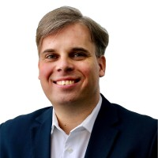  Mr. Aleksandrs Parfjonovs  Vice-Chair  The Representative Office of Joint Stock Company "Grindeks" in Hanoi city  sec.comms@eurochamvn.org  Ms. Magdalena Krakowiak  Vice-Chair  The Representative Office of Adamed Pharma S.A in Vietnam  sec.comms@eurochamvn.org  